FGV SUSTAINABILITY PERFORMANCE AND UPDATES
2022-2024

Contents
1 Monitoring compliance in our supplier’s operation 2
3 Peatland area 5
4 No Open Burning/Use of Fire 5
5 Water Use Intensity 6
5.1 Refinery Water Intensity Performance 7
5.2 Mill Water Intensity Performance 9
6 Water Quality (BOD and COD) 11
6.1 Palm Oil Mill Effluent (POME) 11
6.2 Palm Oil Refinery Effluent (PORE) 12
7 Stakeholder Engagement 15
8 Supplier Engagement on FGV’s Sustainability Compliance 15
9 Climate Risk Assessment (for SPOTT Assessment & Public Disclosure) 16

Monitoring compliance in our supplier’s operation

FGV is committed to responsible sourcing and to ensuring that our raw materials, including Fresh Fruit Bunches (FFB), are not sourced from deforested areas. We use Global Forest Watch (GFW) Pro to trace and monitor deforestation activities within and around our operations as well as those of our suppliers. This platform is an open-source web application that monitors global deforestation rates in near real-time and can detect land-clearing activities that encroach into protected areas.

We have communicated our revised Group Sustainability Policy (GSP) and No Deforestation and Planting on Peat (NDPE) commitments to all our suppliers. We have also measured their sustainability risk levels using the platform. We will verify if any of our suppliers are associated with deforestation activity around their area, and if they are found to be involved, they will be subjected to our Supplier Delinquency Guidelines, which may lead to their removal from our supply chain.

This ensures that only suppliers compliant with Supplier Code of Conduct (SCOC) and our sustainability standards are integrated into our supply chain. We have also appointed a third-party satellite monitoring service to track deforestation, particularly within selected FGV supply bases.

- Enforcing Responsible Sourcing Commitments

FGV’s commitment to sustainability extends beyond our own operations to include our entire supply chain. We believe that all suppliers and contractors must uphold the same values and standards that guide our business. To support this, FGV has implemented a Supplier Code of Conduct (SCOC), which outlines key principles related to sustainability, business ethics, integrity, safety, health, environment, and labour practices. All suppliers and contractors entering business with FGV are required to commit and adhere to these standards.

To ensure continued compliance, all suppliers are subject to independent third-party assessments based on the Malaysian Sustainable Palm Oil (MSPO) and Roundtable on Sustainable Palm Oil (RSPO) standards.

In cases of non-compliance, FGV adopts a proactive approach involving direct engagement and site-level dialogue. Non-compliant suppliers are required to submit a remediation plan, and their progress in implementing the plan is closely monitored. Continued failure to meet standards may result in actions against the suppliers concerned, which may include suspension from our supply chain.

Any deforestation that is detected within our supply base will be managed in accordance with FGV’s GSP Compliance Framework, ensuring appropriate and timely corrective measures.

We also monitor deforestation activities alerted to us by our stakeholders. Since our cut-off date in 2016, the deforestation alerts we have received are as follows:

Alert Year | Total area (ha) | Location | Ownership Concession | Alert Status/Findings
2017 - 2018 | 270 | Sarawak | - Own concession | - Asian Plantations has deforested at least 270 hectares (ha) of potential High Carbon Stock (HCS) forest since September 2017 on its Grand Performance concession.  - A Stop Work Order was immediately issued to APL to halt all land clearing activities at Grand Performance.  - A High Carbon Stock (HCS) assessment was initiated to promptly identify and exclude any areas classified as HCS.  - Despite of some areas were identified as Low Carbon Stock (LCS), FGV chose to preserve the areas as conservation. No land clearing activities have been conducted since the issuance of the Stop Work Order.
2019 | 231 | Hulu Setiu, Terengganu | - External | - Outside FGV & FELDA concession.  - The deforested area is owned by one of our indirect FFB suppliers that is supplied through one of our FFB dealers  - FGV had issued a MEMO to the FFB dealers to not include FFB from the deforested area in our supply base  - An engagement was made with the estate’s owner regarding a remedial and corrective action plan. However, FGV did not receive any response from the owner and has decided to cease business with the estate.
2020 | 4 | PT Citra Niaga Perkasa | - External | - Outside FGV & FELDA concession.  - None of our suppliers are involved in the deforestation activity. The land that was cleared belongs to the local community.
2021 | 8,498 | Mukim Keratong | - External | - Outside FGV & FELDA concession.  - None of our suppliers are involved in the deforestation activity.
2022 | 351 | Jengka 3 | - External | - Outside FGV & FELDA concession. No FFB source from the area for FGV mills.  - None of our suppliers are involved in the deforestation activity.
 | 25 | Mukim Jemaluang, Johor  PTD 1815 concession | - External | - The deforested area is owned by one of our indirect FFB suppliers that is supplied through one of our FFB dealers, AA Sawit.  - FGV had stopped receiving FFB from AA Sawit and engaged with them for a remedial and corrective action plan. However, FGV did not receive any response from AA Sawit and decided to cease business with AA Sawit. The last transaction with AA Sawit was in April 2022.
2023 | 352 | Felda Belara | - External | - Outside FGV & FELDA concession.  - None of our suppliers are involved in the deforestation activity.
 | 496 | Lepar Hilir 05 | - External | - Outside FGV & FELDA concession.  - None of our suppliers are involved in the deforestation activity.
 | 712 | Felda Tersang 03 | - External | - Outside FGV & FELDA concession.  - None of our suppliers are involved in the deforestation activity.
 | 110 | Jengka 2 | - External | - Outside FGV & FELDA concession.  - None of our suppliers are involved in the deforestation activity.

Since the cut-off date on deforestation commitment, we have only received deforestation alerts on two suppliers, cumulatively covering an area of 256 ha. Due to their non-conformance with our policy, we have removed them from our supply base. In 2024, no deforestation activities were reported or detected within our estates and supply base.

Peatland area

Since the adoption of its GSP in 2016, FGV has consistently adhered to the NDPE policy. All existing plantations on peat follow best management practices outlined in the RSPO’s Best Management Practices (BMPs) for Existing Oil Palm Cultivation on Peat. There is no new planting on peat area in FGV since 2016. This can be proven from the total planting area on peatland that has not expanded since the cut-off date. FGV reports a total peatland area of 3,426 hectares, which has remained unchanged since its initial peat inventory for RSPO reporting in 2020.The details of peatland areas within FGV operations are provided below:

Peat Disclosure | 2022 | 2023 | 2024
Area (ha) | 3752 | 3752 | 3426*
*In 2023, FGV divested its 95% equity stake in PT CNP and PT TAA. As a result, 325.6 ha of oil palm plantations on peat under PT CNP have been excluded from FGV’s reported peatland area.

Summary of peat area in FGV are as follows:
Region | Total planted area (Ha) | Summary of peat area (Ha)
 |  | Planted | Unplanted
 |  | Total Area | Conservation | Peat (rehabilitation) | Other
 |  |  | (HCV, HCS, Conservation) |  | (Infra, buildings etc)
Sarawak | 2278.37 | 738.44 | 0 | 0 | 10
Johor | 6692.23 | 970.19 | 249.23 | 31.83 | 0
Terengganu | 2543.26 | 280 | 164.03 | 0 | 0
Perak | 2151.21 | 496.92 | 0 | 0 | 0
Sabah | 4051.81 | 940.8 | 464.52 | 0 | 0

No Open Burning/Use of Fire

FGV strictly adheres to a zero-burning policy and does not practice open burning except for managing the outbreak of pests and diseases as specified in the ‘Guidelines for the Implementation of the ASEAN Policy on Zero Burning 2003’ and with regulatory approval. Natural fires, however, may still occur in some regions during times of severe dry weather. Despite our best efforts to prevent any fire, there are still fire incidents occurring on and around our premises. The areas and sizes of the affected area are as below:

Area /Year | 2022 | 2023 | 2024
Total area burnt (Ha) – planted area | 4.71 | 1.6 | 3.5
Total area burnt (Ha) – unplanted/mill area | 0.6 | 0.9 | 0.1
Total area burnt (Ha) – outside concession | - | 1.2 | 1.2
Total area burnt (Ha) – Overall | 5.31 | 3.7 | 4.8

Spontaneous burning is due to hot weather and dry season in Malaysia while accidental or intentional burning by local communities is the primary cause of fire around our plantations in Indonesia.

Water Use Intensity

FGV is committed to achieving water neutrality throughout its operations. To this end, the company continuously monitors its water consumption and water intensity at its mills and refineries.

FGV operates 63 palm oil mills and 4 refineries. Generally, FGV’s palm oil mills use water drawn from natural streams while FGV’s refineries use pipe water supplied by state or national water agencies.

The water usage data presented for the facilities in 2022-2024 consists of water use intensity and projected targets. The water use intensity is determined by the water usage volume over the tonnage of raw material processed while the water intensity targets are projection based on the production forecast plan, developed earlier in each year (i.e. projected targets).

The current water intensity and projected targets are based on total water consumption in the facility, which includes both maintenance and processing activities. However, this method does not accurately reflect true water efficiency, as it combines fixed water usage for maintenance with variable usage for processing (that varies depending on the quantity of crude palm oil (CPO) or Fresh Fruit Bunch (FFB) processed in a year).

Recognising this limitation, a decision has been made to segregate water usage into two distinct categories—maintenance and processing—starting from 2025. This approach will facilitate more accurate and transparent reporting by separately tracking fixed and variable components of water use. Only processing water usage will be used as the basis for measuring water intensity and efficiency within the production process

The previous reporting method, which aggregated total water use, failed to account for fluctuations in processing volume from year to year. As a result, the average water intensity figures recorded were not directly comparable across years. By introducing this new method of measurement, we aim to improve data comparability and enable more meaningful analysis of water performance over the years, particularly in relation to sustainability targets from 2025 onwards. To further improve water usage efficiency, FGV has set a clear water intensity target specific for operations effective from 2025 to enable effective comparison over time.

Refinery Water Intensity Performance

For the refineries, the water intensity is measured by the water usage volume over the tonnage of crude palm oil (CPO) processed. The water intensity performance is as follows:
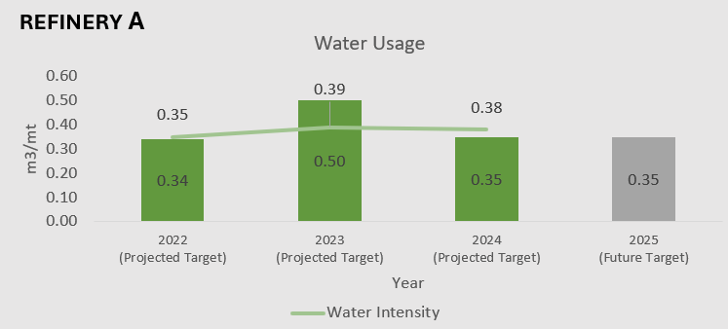
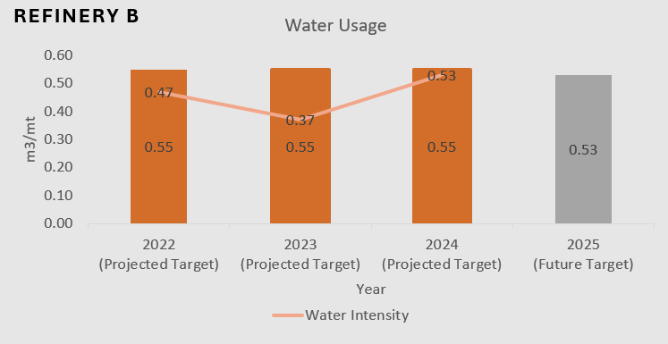
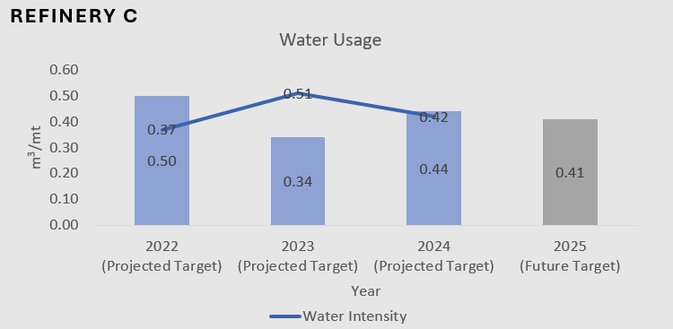
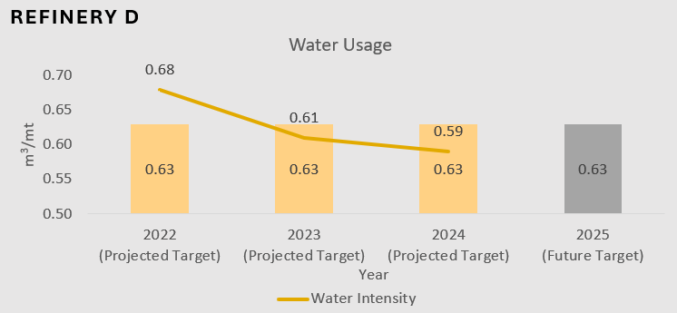

- Refineries B, C and D achieved lower water intensity levels compared to their annual projected targets.

- The other one refinery exceeded the annual projected water intensity targets due to operational factors.

The average water intensity across all refineries in 2024 was recorded at 0.48 m³/mt of CPO processed, slightly higher than the average of 0.47 m³/mt in 2022 and 2023. However, there was an improvement in overall water management performance, as only one refinery exceeded the target in 2024 compared to two in 2023.

Mill Water Intensity Performance

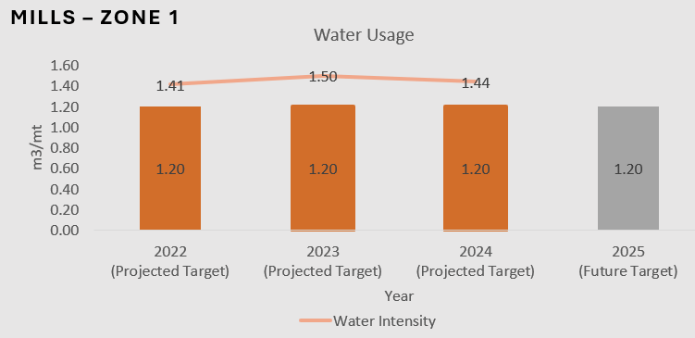
As for the mills, the water intensity is measured by the water usage volume over the tonnage of fresh fruit bunch (FFB) processed. The water intensity performance is as follows:

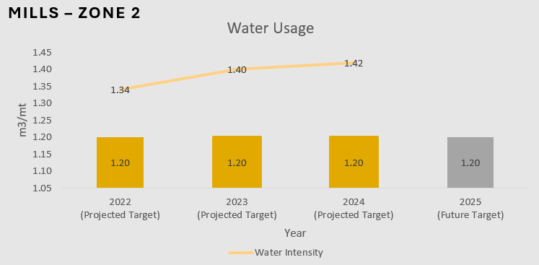

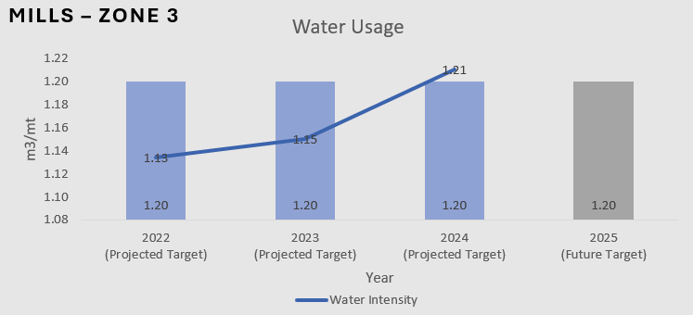
- Zone 1, Zone 2 and Zone 3, representing Peninsular Malaysia 1, Peninsular Malaysia 2 and West Malaysia’s mills, respectively, exceeded their annual projected water intensity targets due to operational factors.

On average, the 2024 water intensity across all mills increased by 0.49% compared to 2023, from 1.35 m³/mt FFB processed in 2023 to 1.36 m³/mt FFB processed in 2024.
FGV continues to closely monitor and work towards improving the water neutrality of its operations to meet these long-term sustainability goals.

Water Quality (BOD and COD)

As FGV is committed to ensuring our operation does not give an adverse impact on the environment. We conduct daily, weekly, and monthly effluent performance monitoring that involves lab analyses and checks on the physical condition of our POME and PORE treatment systems. We continuously ensure that our discharge does not exceed the limit set by the Department of Environment (DOE) Malaysia, which is also our internal target to be achieved by 2025.

Palm Oil Mill Effluent (POME)

Our POME records in 2022, 2023 and 2024 are as follows:

Watercourse Discharged

Region | 2022 | 2023 | 2024 | LIMIT DOE
Johor (1 mill) | 20 | 19 | 18 | 20
Johor (8 mills) | 60 | 44 | 50 | 100*
Kelantan (3 mills) | 53 | 52 | 60 | 100
Negeri Sembilan (3 mills) | 72 | 70 | 63 | 100
Pahang (25 mills) | 81 | 67 | 73 | 100
Perak (2 mills) | 50 | 45 | 50 | 100
Selangor (1 mills) | 82 | 24 | 35 | 100
Terengganu (4 mills) | 74 | 71 | 78 | 100
Sarawak (1 mill) | 49 | 50 | 32 | 100
Sarawak (1 mill) | 10 | 13 | 13 | 20
Sabah (1 mill) | 19 | 17 | 14 | 20
Sabah (1 mill) | 52 | 66 | 56 | 100

Note:
*The Department of Environment Johor set a new POME discharge limit of 20 mg/L for the Johor region in 2021. However, FGV has been granted an extended mediation period until 31 August 2025 to upgrade the POME treatment plants at eight (8) of its mills in the region. Therefore, the current permissible POME discharge limit for these eight (8) FGV mills remains at 100 mg/L until the end of the mediation period.

Land Discharged
Region | 2022 | 2023 | 2024 | DOE Limit (mg/L)
Johor (1 mill) | 39 | 51 | 57 | 100
Johor (3 mills) | 91 | 71 | 136 | 5000
N. Sembilan (1 mill) | 219 | 244 | 125 | 500
N. Sembilan (1 mill) | - | - | 107 | 5000
Pahang (2 mills) | 94 | 108 | 98 | 5000
Sabah (6 mills) | 43 | 48 | 55 | 100
Sabah (2 mills) | 11 | 10 | 8 | 20

Palm Oil Refinery Effluent (PORE)

Our PORE records in 2021 2022, 2023 and 2024 are as follows:

Facility: Refinery A
Months/ Year | COD Result |  |  |  | COD Target | BOD Result |  |  |  | BOD Target
 | 2021 | 2022 | 2023 | 2024 |  | 2021 | 2022 | 2023 | 2024
Jan | 158 | 75 | 80 | 59 | 200ppm< | 15 | 14 | 21 | 15 | 50ppm<
Feb | 128 | 51 | 43 | 114 |  | 14 | 10 | 24 | 10
Mar | 121 | 42 | 49 | 113 |  | 16 | 6 | 12 | 20
Apr | 129 | 35 | 41 | 89 |  | 15 | 7 | 10 | 9
May | 141 | 38 | 90 | 79 |  | 11 | 5 | 19 | 6
Jun | 172 | 54 | 95 | 72 |  | 13 | 12 | 17 | 6
Jul | 150 | 69 | 41 | 86 |  | 13 | 14 | 14 | 5
Aug | 155 | 28 | 128 | 96 |  | 13 | 6 | 23 | 7
Sep | 174 | 52 | 68 | 128 |  | 7 | 15 | 19 | 2
Oct | 111 | 115 | 35 | 112 |  | 13 | 19 | 9 | 10
Nov | 107 | 46 | 48 | 110 |  | 18 | 9 | 10 | 3
Dec | 99 | 41 | 29 | 52 |  | 9 | 10 | 7 | 4

Facility: Refinery B
Months/ Year | COD Result (ppm) |  |  |  | COD Target | BOD Result (ppm) |  |  |  | BOD Target
 | 2021 | 2022 | 2023 | 2024 | (ppm) | 2021 | 2022 | 2023 | 2024 | (ppm_
Jan | 31 | 27 | 50 | 20 | 200ppm< | 3 | 3 | 10 | 2 | 50ppm<
Feb | 27 | 39 | 27 | 19 |  | 3 | 5 | 4 | 2
Mar | 20 | 27 | 39 | 95 |  | 3 | 3 | 3 | 10
Apr | 31 | 43 | 23 | 71 |  | 4 | 8 | 3 | 6
May | 16 | 37 | 62 | 44 |  | 3 | 4 | 14 | 3
Jun | 51 | 23 | 33 | 38 |  | 6 | 3 | 5 | 5
Jul | 27 | 19 | 35 | 52 |  | 4 | 2 | 3 | 2
Aug | 19 | 58 | 19 | 45 |  | 2 | 10 | 2 | 2
Sep | 54 | 23 | 19 | 63 |  | 12 | 3 | 2 | 12
Oct | 23 | 37 | 16 | 47 |  | 3 | 6 | 2 | 4
Nov | 16 | 15 | 32 | 55 |  | 2 | 3 | 4 | 3
Dec | 23 | 49 | 27 | 41 |  | 3 | 7 | 4 | 3

Facility: Refinery C
Months/ Year | COD Result |  |  |  | COD Target | BOD Result |  |  |  | BOD Target
 | 2021 | 2022 | 2023 | 2024 |  | 2021 | 2022 | 2023 | 2024
Jan | - | 65 |  | 34 | 200ppm< | - | 32 |  | 11 | 50ppm<
Feb | 34 | - |  | - |  | 13 | - |  | -
Mar | - | 20 |  | - |  | - | 7 |  | -
Apr | 135 | 22 |  | - |  | 20 | 6 |  | -
May | - | - |  | 10 |  | - | - |  | 2
Jun | 29 | - |  | - |  | 2 | - |  | -
Jul | - | - |  | 15 |  | - | - |  | 2
Aug | - | - |  | - |  | - | - |  | -
Sep | - | - |  | 16 |  | - | - |  | 5
Oct | - | - |  | - |  | - | - |  | -
Nov | 56 | - |  | 16 |  | 14 | - |  | 5
Dec | - | 23 |  | - |  | - | 7 |  | -
Remark: FGVR Tawau only do the analysis when plant is running

Facility: Refinery D
Months/ Year | COD Result (ppm) |  |  |  | COD Target | BOD Result (ppm) |  |  |  | BOD Target
 | 2021 | 2022 | 2023 | 2024 | (ppm) | 2021 | 2022 | 2023 | 2024 | (ppm_
Jan | 62 | 48 | 74 | 63 | 400 | 20 | 15 | 19 | 19 | 50
Feb | 59 | 48 | 95 | 53 |  | 19 | 15 | 15 | 16
Mar | 64 | 49 | 59 | 49 |  | 17 | 14 | 17 | 16
Apr | 49 | 44 | 52 | 37 |  | 15 | 14 | 15 | 10
May | 54 | 61 | 67 | 62 |  | 17 | 17 | 18 | 18
Jun | 35 | 56 | 69 | 35 |  | 11 | 18 | 18 | 12
Jul | 31 | 63 | 63 | 23 |  | 10 | 20 | 18 | 8
Aug | 31 | 62 | 47 | 50 |  | 11 | 18 | 14 | 15
Sep | 35 | 51 | 31 | 44 |  | 11 | 15 | 9 | 13
Oct | 48 | 78 | 46 | 41 |  | 14 | 20 | 14 | 13
Nov | 35 | 48 | 55 | 42 |  | 11 | 14 | 22 | 14
Dec | 46 | 72 | 40 | 29 |  | 16 | 22 | 12 | 10

Facility: Refinery E
Months/ Year | COD Result (ppm) |  |  |  | COD Target | BOD Result (ppm) |  |  |  | BOD Target
 | 2021 | 2022 | 2023 | 2024 | (ppm) | 2021 | 2022 | 2023 | 2024 | (ppm)
Jan | 235 | 319 | 154 | 79 | 200 ppm< | 37 | 103 | 29 | 23 | 50 ppm<
Feb | 250 | 250 | 119 | 86 |  | 44 | 24 | 25 | 28
Mar | 446 | 207 | 47 | 98 |  | 77 | 48 | 18 | 22
Apr | 350 | 131 | 285 | 36 |  | 43 | 26 | 60 | 8
May | 391 | 118 | 198 | 17 |  | 60 | 32 | 35 | 5
Jun | 266 | 287 | 97 | 13 |  | 47 | 57 | 27 | 3
Jul | 1660 | 88 | 75 | 88 |  | 305 | 25 | 30 | 15
Aug | 839 | 279 | 57 | 62 |  | 99 | 21 | 23 | 15
Sep | 321 | 116 | 2420 | 60 |  | 70 | 34 | 177 | 10
Oct | 209 | 93 | 14412 | 33 |  | 52 | 26 | 2920 | 9
Nov | 261 | 76 | 156 | 46 |  | 50 | 16 | 49 | 13
Dec | 130 | 164 | 424 | 109 |  | 27 | 31 | 29 | 27

Stakeholder Engagement

FGV prioritizes stakeholder engagement as a key component of its sustainability strategy, ensuring open communication and minimizing potential conflicts, especially with local communities.

We engage stakeholders through Social Impact Assessments (SIAs), High Conservation Value (HCV) assessments, and structured consultation programs. These activities, aligned with RSPO and MSPO requirements, are conducted across all certified areas. We also conducted stakeholder consultation programmes with the aim to communicate our sustainability commitments and gather feedback on the impacts of our operations to stakeholders including local communities.

In 2024, FGV conducted 14 stakeholder consultation sessions. Participants of these sessions included local authorities, smallholders, FELDA settlers, and community representatives such as Ketua Kampung, Ketua Peneroka, and Tok Batin. The sessions were attended by a total of approximately 1,250 participants. Any arising issues or concerns, including potential conflicts, are addressed constructively through these dialogues. In cases involving land disputes, FGV follows its Identification and Resolution of Land Disputes Procedure to ensure fair and transparent resolution.

Supplier Engagement on FGV’s Sustainability Compliance

At FGV, ensuring responsible sourcing of raw materials is a cornerstone of our commitment to sustainability. We actively engage with our suppliers to uphold these standards, fostering compliance with our sustainability commitments across our supply chain. In 2024, we have conducted 16 comprehensive sessions of engagements through the Direct Fresh Fruit Bunches (FFB) Supplier Programme, where 76% of the attendees are from independent smallholders’ category, 14% are from dealers and 10% are from private estates.

We have also conducted 29 sessions with the suppliers to raise their awareness on the sustainability standards and the importance of adopting sustainable practices. The objective of the session is to raise their awareness on the sustainability standards and the importance of adopting sustainable practices.

During these engagements, we evaluated our suppliers’ compliance with FGV’s sustainability standards, ensuring alignment with our commitment to environmental, social and governance (ESG) principles. This proactive strategy enhances the resilience of our supply chain while reaffirming our commitment to sustainability across all operations. Through strong partnerships and thorough assessments, FGV remains focused on driving positive change toward a more sustainable future. We also conduct regular performance monitoring to identify, manage, and mitigate sustainability-related risks within our supplier network.

Climate Risk Assessment (for SPOTT Assessment & Public Disclosure)

Current Implementation
FGV’s Risk Management Framework, aligned with ISO 31000:2018, is structured to integrate risk identification, assessment, and mitigation into business decision-making. This approach enhances resilience, promotes clarity, and ensures proactive risk management in support of FGV’s strategic objectives. Climate risks are embedded within existing categories such as strategic, geopolitical, operational (including financial related, safety), market and technology, as well as reputational risks (policy and regulations), enabling alignment with core business processes and risk appetite. The potential climate-related impacts on business continuity, operational performance, and stakeholder value are proactively monitored via identified mitigation and key risk indicators.

FGV uses the Enterprise Risk Management System (ERMS) to identify and monitor all material risks, including those related to climate change. The Risk Champions across divisions, together with the Group Risk Department (GRD), are responsible for ensuring that risks are identified, assessed, and escalated appropriately. These risks are also reviewed and endorsed through established governance structures involving both management and board-level committees via the Risk Management Committee (RMC) and Board Governance and Risk Management Committee (BGRMC) respectively. Strategic oversight over the implementation of the Group’s ESG commitments, including on climate-related issues, is provided by the Board Sustainability Committee (BSC) and Board, which are supported by the Sustainability Steering Committee (SSC). In a recent scanning of risk records within the ERMS, sample of risk registers were identified having relevance to climate change factors, highlighting the increasing importance of addressing climate-related issues.

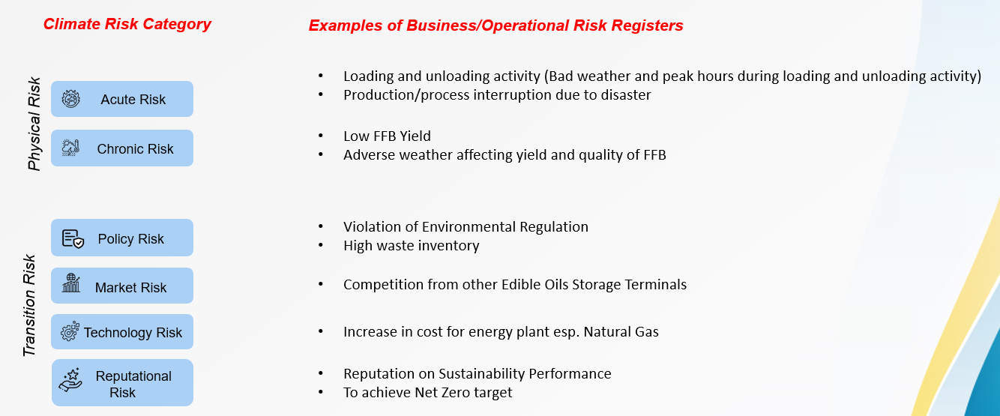
To further institutionalise this integration, FGV has embedded climate risk consideration into investment decisions and papers in assessing climate-related risks and their potential impact on project viability, costs, and long-term value creation. This step enhances decision-making by incorporating sustainability considerations into capital allocation and strategic planning.

Improvement

As of 2024, the identification of climate risks is performed through manual review based on the exposure and prioritisation of the identified risk to the company. In addition, climate-related opportunities are not formally recorded at present, which is an area for future enhancement.

To further enhance the robustness and maturity of its climate risk management framework, and to align with global best practices, FGV has developed and approved a Climate Risk Identification and Implementation Roadmap (2025–2026), in alignment with IFRS Sustainability Disclosure Standards and Task Force on Climate-related Financial Disclosures (TCFD) recommendations. The roadmap was presented to and formally endorsed by FGV’s SSC, chaired by the Group Chief Executive Officer, in May 2025.

The key focus areas of this strategic roadmap include:
- Integration of climate scenario analysis to assess potential future climate-related outcomes and their business impacts.
- Mapping long-term climate risk horizons to understand and prepare for evolving risk exposures over short, medium, and long-term timelines.
- Conducting quantitative impact assessments to evaluate the financial and operational implications of identified climate risks.
- Systematically linking climate risks with strategic business and financial planning, ensuring climate considerations are embedded within decision-making processes at all levels of the organization.

FGV acknowledges that while the current ERMS provides a strong and credible foundation, further enhancement is required to fully meet evolving regulatory expectations and standards, such as IFRS Sustainability Disclosure Standards and other emerging frameworks.

FGV remains firmly committed to continuously strengthening and evolving its climate risk management framework. This ongoing effort aims to support enhanced business resilience, promote more informed and forward-looking decision-making, and enable more transparent and credible disclosures to its wide range of stakeholders, including investors, regulators, customers, and the broader community.

